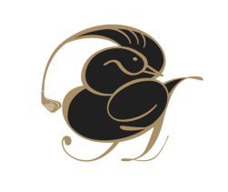
WABLGA Pennant Report 2022

The WABLGA Pennant Season for 2022 concluded with the Pennant Final being held at Bunbury Golf Club on Sunday, 31st July 2022. Thank you to Bunbury GC, Julie Rodgers and her band of Merry Elves for their wonderful hospitality on the day. The Christmas in July theme was very well received and appreciated.
I am pleased to announce Royal Perth Golf Club as the 2022 WABLGA Pennant Champions. The results of the Pennant Final Round are as follows:
GREEN DIVISION |  |  |  | GOLD DIVISION
Rank | Club | Score |  | Rank | Club | Score
2 | Lake Karrinyup | 2 | v | 1 | Royal Perth | 3
4 | WAGC | 3 | v | 3 | The Vines 1 | 2
6 | The Vines 2 | 2.5 | v | 5 | Mt Lawley | 2.5
8 | Bunbury | 2 | v | 7 | Gosnells | 3
9 | Royal Fremantle | 4 | v | 10 | Mandurah | 1
12 | Pinjarra | 2 | v | 11 | Mosman Park | 3
From these results, the proposed divisions for 2023 are as follows:
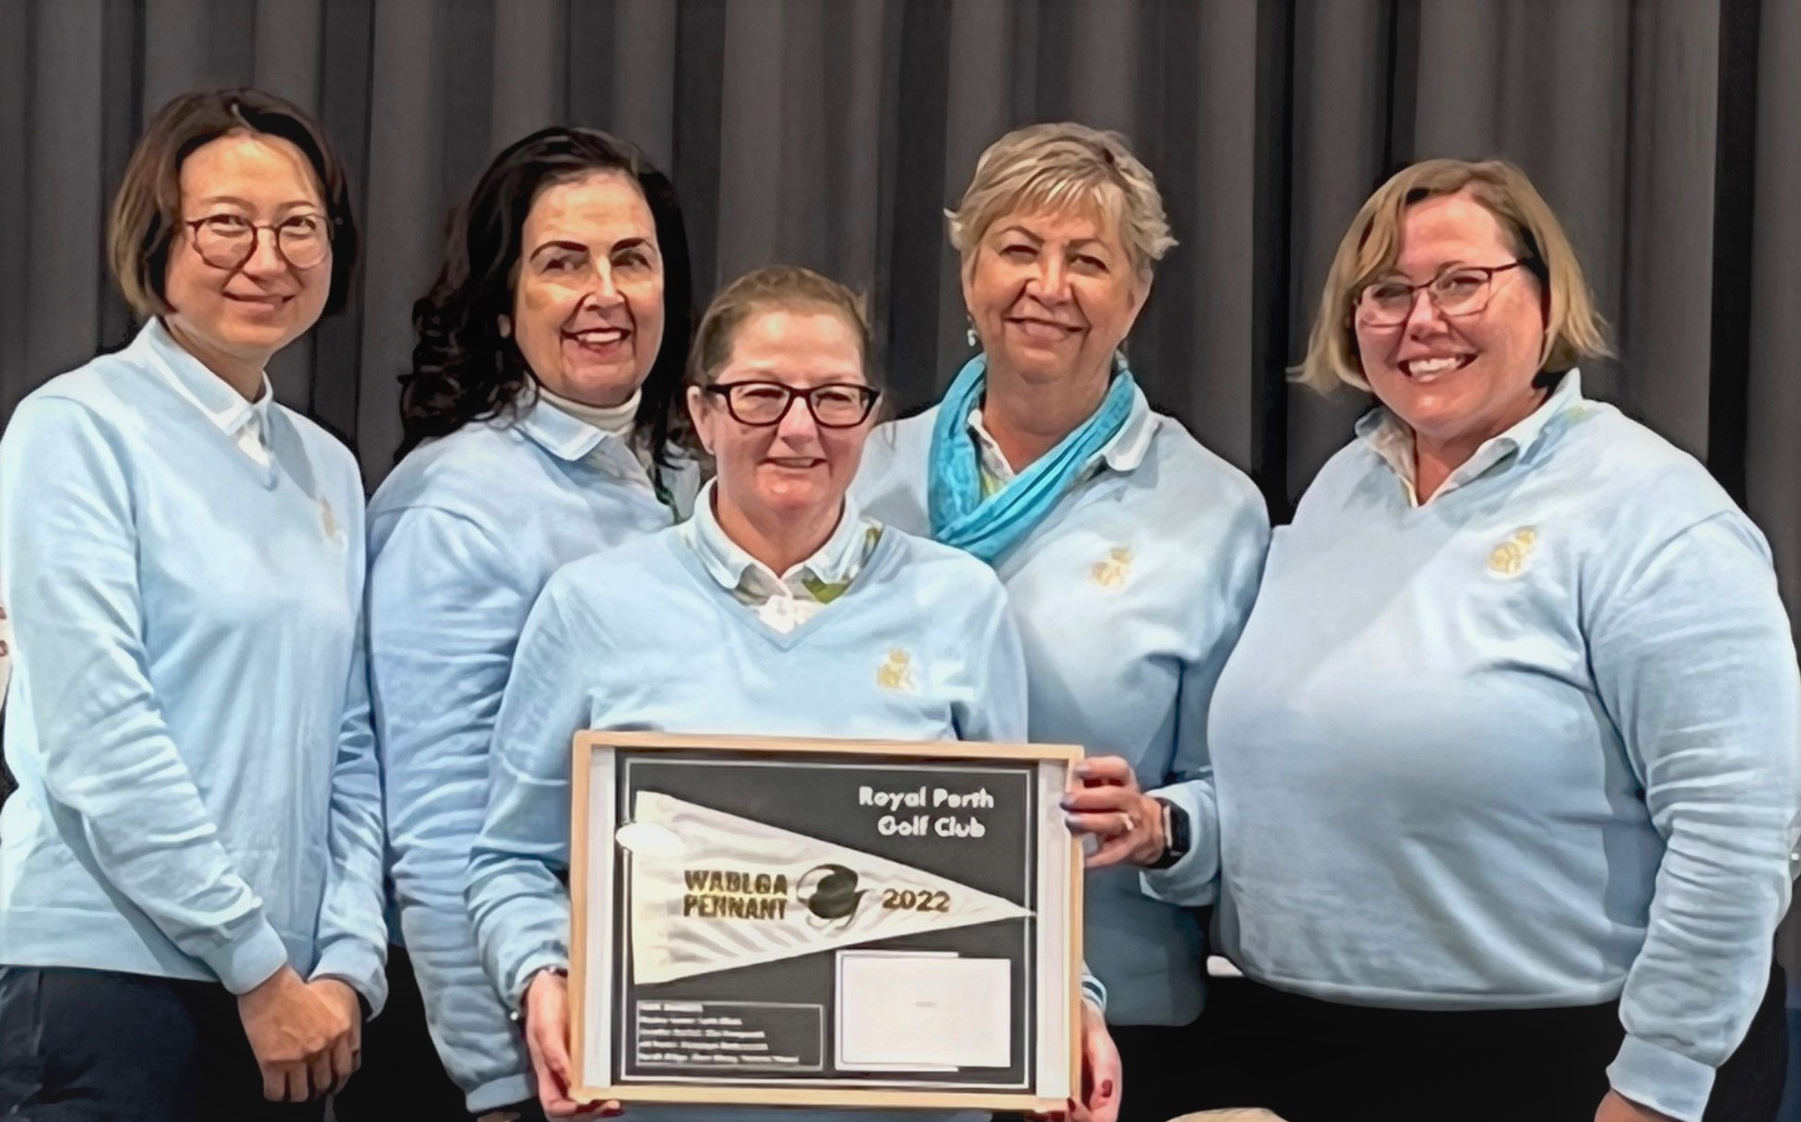
1st | Royal Perth
2nd | Lake Karrinyup
3rd | WAGC
4th | The Vines (1)
5th | Mt Lawley
6th | Gosnells
7th | Bunbury
8th | Royal Fremantle
9th | Mandurah
10th | Mosman Park
11th | Pinjarra
12th | To Be Advised
L to R: Chen Wang, Jennifer Garlick, Ola Hempseed, Jill Penter,
Leith Elliott (Capt), Absentee: Penelope Radunovich
Ros Fisher Trophy for 2022
A total of 97 players participated across the 5 rounds of the 2022 Pennant season and the winner of the Ros Fisher Trophy for Best Pennant Player of the Season was Jan Rawling from Gosnells GC who won all 5 matches with 13 points.
ROS FISHER TROPHY 2022 |  | Total | Wins | 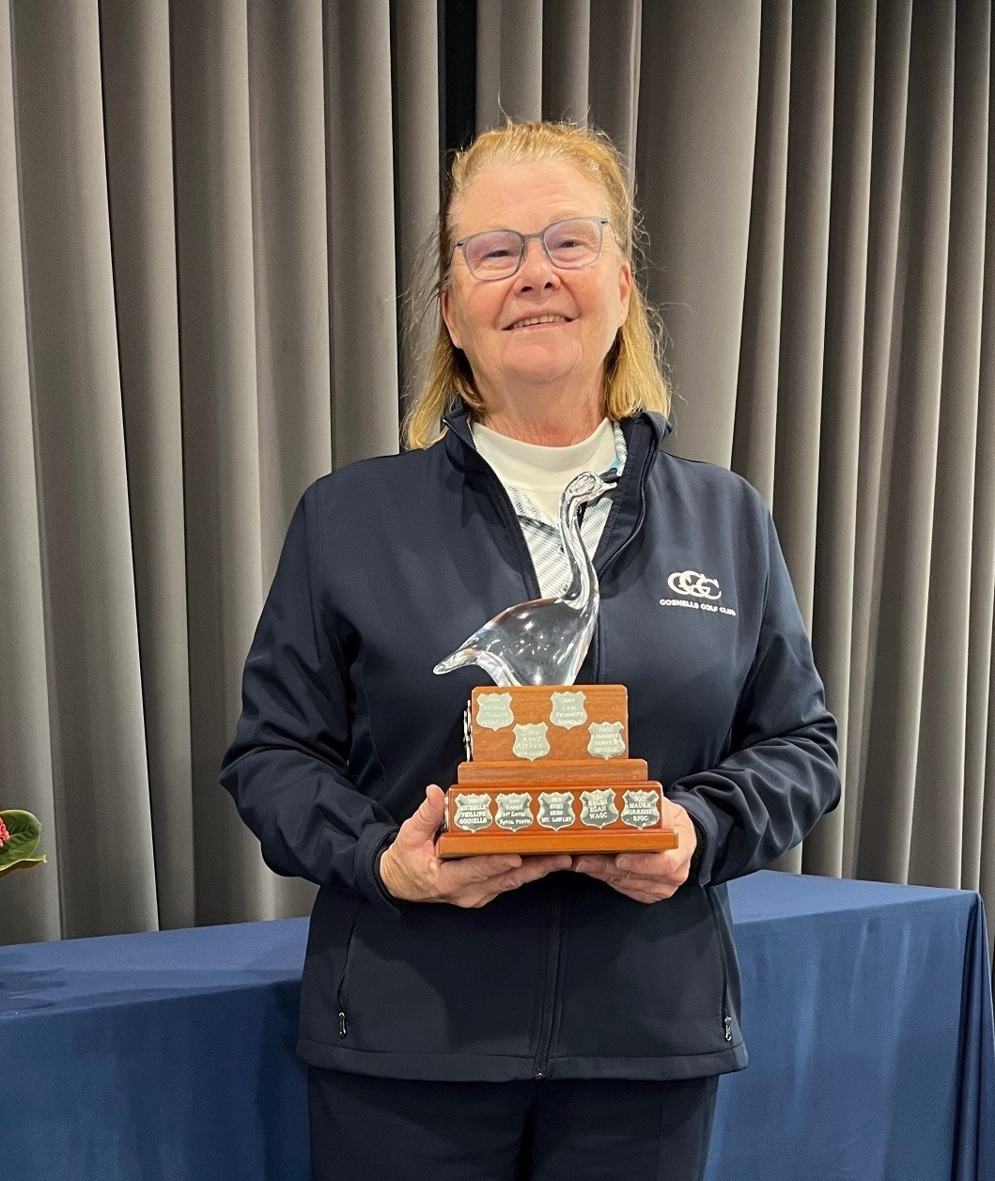
 |  | Points
1st | Jan Rawling (Gosnells) | 13 | 5
2nd | Rita Semple (Bunbury) | 11.5 | 4.5
3rd | Christine Armanesco (The Vines 2) | 14.5 | 4
4th | Angie Bell (The Vines 1) | 14 | 4
Equal 5th | Lindsay McCabe (The Vines 1) | 9 | 4
Equal 5th | Alison Oliver (WAGC) | 9 | 4
Jan Rawling – Gosnells GC
Winner – Ros Fisher Trophy

Thank you to everyone for your help and support throughout this pennant season. It has been a steep learning curve for me with a few hiccups along the way for which I am grateful for your understanding. The weather seemed kinder to us this year, with fewer rainy days.
A special thank you goes to all the hosting clubs and their ladies for outstanding hospitality (Pinjarra, The Vines, Mandurah, Royal Perth, Mt Lawley, and Bunbury) and Care Bags fundraising efforts in 2022.
Happy golfing for the remainder of the year.
Shonna Gobby – Pennant Coordinator 2022

CONSIDERATIONS FOR 2023 WABLGA PENNANT SEASON :
- Pennant season dates through winter or alternate – look at draft fixtures for men’s and women’s pennants in Perth; consider playing very early or late in the year. Early discussion with GolfWA regarding the tentative programming of the fixtures for the 2023 Season.
- The number of Clubs that will be able to field a Pennant Team for 2023 with the changes that are being implemented at Clubs relating to changes of Membership Categories.

